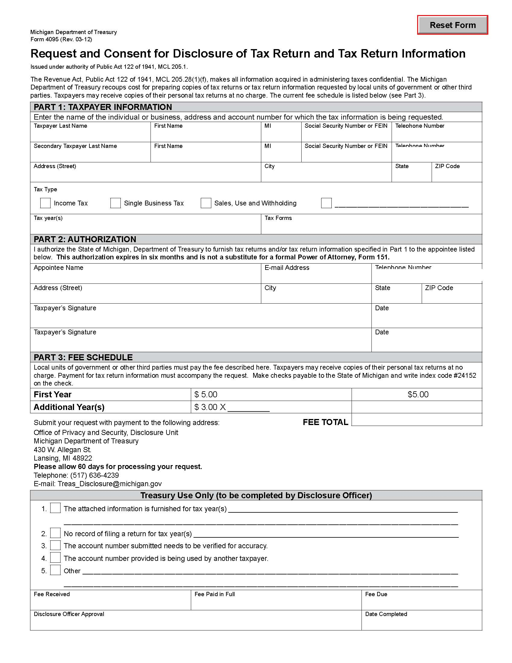

Order No. 01-28518 - 002
John Randall Adkins
XXX-XX-5529

Axiom Requisition Copy Service records@axiomcopy.com (877) 886-5090

2869 Jolly Road Okemos MI 48864

X
Income

